- create the DEPT table based on the following table instance chart.
Ans→create table dept(id number(7) not null
name varchar2(25) not null,
constraint Id_PK primary key(id) );

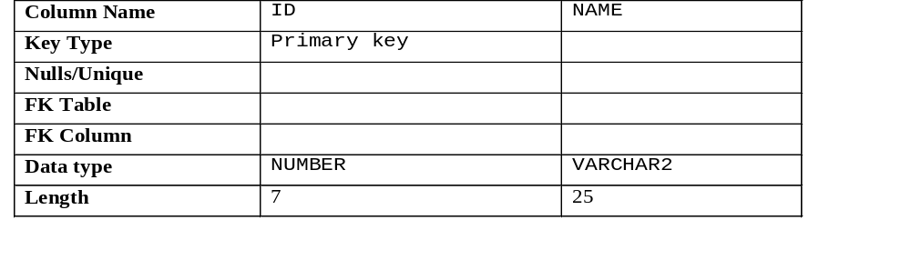

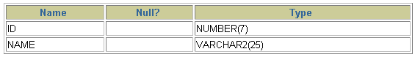

- Populate the DEPT table with data from the DEPARTMENTS table. Include only columns that you need.
ANS→insert into dept values(2575, ’suhel’);

- Create the EMP table based on the following table instance chart. Confirm that the table IS created.
ANS→create table emp(
id number(7) not null,
last_name varchar2(25) not null,
first_name varchar2(25) not null,
dept_id number(7) not null,
constraint dept _id_pk foreign key (dept_id)REFERENCES DEPT(DEPT_ID) );

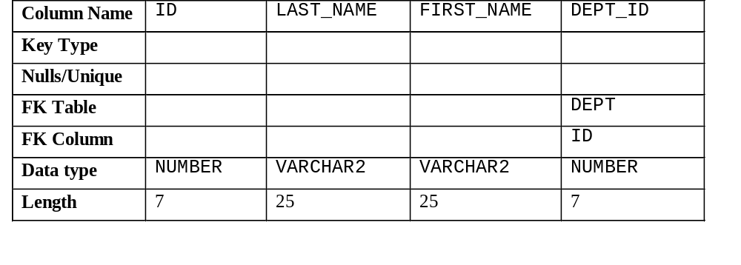

DESCRICE EMP;
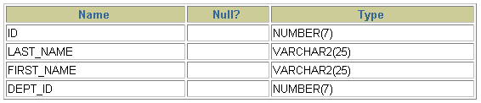
- Create the EMPLOYEES2 table based on the structure of the EMPLOYEES table. Include only the EMPLOYEE_ID, FIRST_NAME, LAST_NAME, SALARY, and DEPARTMENT_ID columns. Name the columns in your new table ID, FIRST_NAME, LAST_NAME, SALARY , and DEPT_ID, respectively.
ANS→ create table employee2 (
employee_id number(8) not null ,
first _name varchar2(20) not null,
last_name varchar2(20) not null,
salary number(8) not null,
constraint employee_id_pk primary key(employee_id) ,
constraint sal_sl check(‘sal’>0 ) );

5. Drop the EMP table.
ANS→DROP TABLE EMP ;

